What are the TOP 3 criteria that a 21st Century Library needs!?

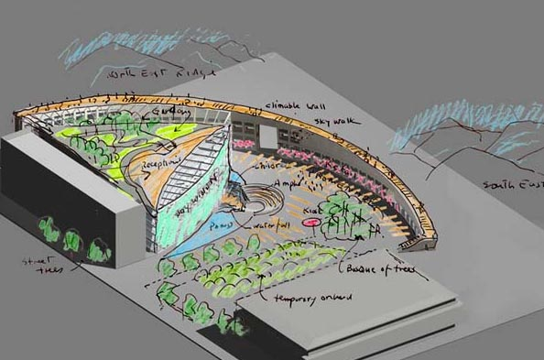
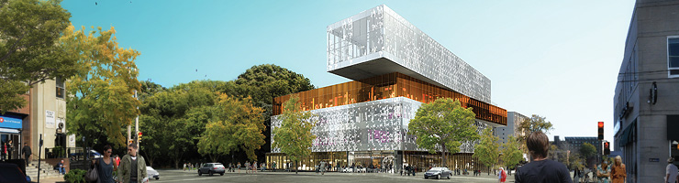
http://halifaxcentrallibra ry.ca/ building-design/

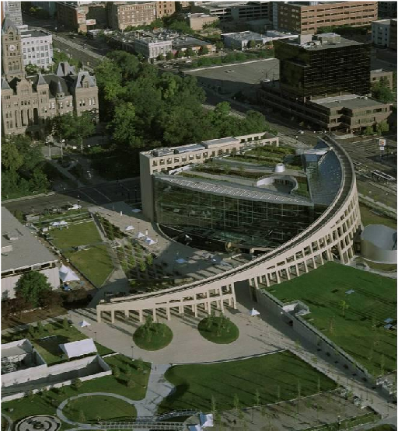

http://www.msafdie.com/#/projects/saltlakecitymainpubliclibrary

http://keskustakirjasto.fi/en/2011/07/29/denmark-sets-an-example-urban-mediaspace-aarhus/

